HOUSEHOLD
EMERGENCY
PLAN

If you think your life or the life of someone else is in danger always call 999

PREPARE
RESPOND
RECOVER

Template prepared by:
Emergency Management Service
Swansea Council

Introduction - Your household emergency plan

Emergencies can affect anybody with little or no notice. Being prepared can help reduce the effects on people’s lives, reduce the need for support from others and enable you to support the vulnerable members of your street and community.

Emergencies such as floods, fires, gas explosions and bomb threats may require you to leave your home for short periods of time. Other incidents such as disruption to essential services that we all rely upon (such as water, electricity, telecommunications and travel networks) or being stranded due to adverse weather or illness are not always an emergency but can affect our everyday lives.

If you are involved in an incident and believe you may be in danger always dial 999 and request the appropriate emergency assistance.

If however you are not in danger but may be affected indirectly, you may be advised to:

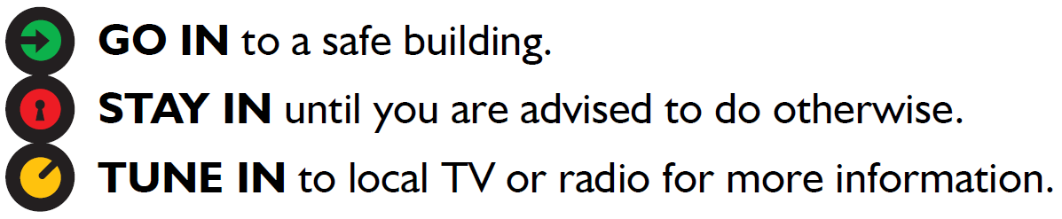

Complete the following sections where required, print out his plan and keep it in a safe and accessible place in your home or in your grab bag.

Section 1 - Where to obtain further information in an emergency
Radio Station | Frequency | Website
BBC Radio Wales | 95.1 FM | www.bbc.co.uk/wales
Heart FM | 106 FM | www.heart.co.uk/southwales
The Wave | 96.4 FM | www.thewave.co.uk

During a national power outage, only the following radio stations will continue broadcasting and will provide information and updates:

Radio Station | Frequency
BBC Radio Two | 88.4 FM
BBC Radio Four | 92.8 FM

The following social media pages will help to keep you informed about current situations during emergencies:
Organisation | Twitter
South Wales Police | @swpolice
Mid and West Wales Fire and Rescue Service | @mawwfire
Swansea Council | @SwanseaCouncil
Natural Resources Wales (Flooding emergencies) | @NatResWales
Met Office (Weather related emergencies) | @metoffice

Section 2 - Useful telephone numbers

For any emergencies where there is danger to life, call 999 straight away.

Contact Name | Contact Number
South Wales Police | 101 (non emergencies)
Mid and West Wales Fire & Rescue Service | 0370 6060699
Swansea Council | 01792 636000
Natural Resources Wales Floodline | 0345 988 1188
NHS | 111
Welsh Water | 0800 052 0130
Wales & West Utilities | 0800 111 999
National Grid | 105
Doctors Surgery
Dentist
School
Home Insurance
Car Insurance
Work Number 1
Work Number 2
Gas Supplier
Electricity Supplier

Household contact details
Use this section to list the members of your household and family / friends that you may need to get in touch with during an emergency

Contact Name | Phone number

Section 3 – Evacuation

Creating an emergency grab bag

It is recommended that you have an emergency bag to hand or available in case of emergency evacuation or being stranded in your home. It would be useful if the bag contained the following items:
- Mobile phone and charger  - Medicines and prescriptions  - Toiletries  - Identity documents (passports/drivers licence)  - First aid kit  - Radio (battery or wind-up)  - Torch (battery or wind-up)  - Spare batteries  - Notebook, Pen/pencil  - Copies of car and home insurance documents | - Change of clothes  - Blankets  - Baby food and accessories  - Children’s toys/activities  - Bottled water  - Non-perishable food/snacks  - Spare keys for house  - Money  - Glasses/contact lenses  - Pet food and accessories
Utility information

If required to evacuate your home, before leaving consider the need to turn off the following:

Utility | Location of your isolation / turn off point | Tick when done
Gas
Electricity
Water
Heating oil

Meeting / relocation point

If you are evacuated as a household or are unable to contact each other, where will you meet or relocate to? Use the space below to list appropriate places of refuge, for example friends or family.

Can you support others in your community or nearby residents?

If during times of emergency you are able to provide support or help to others in your street or community (e.g. the elderly, young and vulnerable) use the space below to list contact details of neighbours or community members that agree to share their contact details with you.

Name | Address | Phone Number

Section 4 - Emergency action check list

This section contains a check list which should be followed in the event of an incident or emergency where you are required to use the content of your plan.

Step | Action to be taken | Tick when done
1 | If you believe there is a danger to life, call the emergency services. Don’t assume someone else has already done it!
2 | Ensure you are not in any danger in your current location and if required move to a safe place.
3 | Do you need to evacuate your property or have you been advised to by the emergency services? If so, advise a family member or friend where you are going and how you can be contacted.
4 | Consider contacting neighbours or others who may be affected by the situation. Refer to section 3.
5 | Carry out the necessary actions to keep you and your family safe. If evacuating consult your pre-planned actions and remember to take your pre-packed emergency grab bag. If remaining in your home obtain information from the sources listed in this plan and notify people on your list to confirm that you are safe. Inform an unaffected family member, friend or neighbour of your actions.

Section 5 - Additional notes / information

