

DEDDF COFRESTRU TIROEDD COMIN 1965 - ADRAN 13
Hysbysiad o Gais i Ddiwygio Cofrestr

Hawliau Tir Comin o Uned Cofrestru CL:003 Ryers Down Common

Cais Rhif: 001-23/CR

Gwnaed cais i Awdurdod Cofrestru Dinas a Sir Abertawe gan Mr Matthew Straker and Mrs Jane Straker of Bayview Farm, Llanmadoc, Swansea, SA3 1DE i ddiwygio'r Gofrestr Tiroedd Comin mewn perthynas â'r Hawl Tir Comin cofrestredig y rhoddir ei manylion yn Rhan 1 yr Atodiad i hyn. Honnir, oherwydd y materion a grybwyllwyd yn Rhan 2 yr Atodiad hwnnw, y dylid diwygio'r gofrestr fel a nodir yn Rhan 3 i hyn.

Dylai unrhyw berson sy'n derbyn yr hysbysiad hwn sy'n dymuno gwrthwynebu'r diwygiad arfaethedig, o fewn deugain niwrnod i ddyddiad yr hysbysiad hwn, anfon datganiad ysgrifenedig wedi'i lofnodi o'r ffeithiau y mae'n seilio'i wrthwynebiad arnynt at y:

Cyfarwyddiaeth Lleoedd
Cynllunio ac Adfywio'r Ddinas
Awdurdod Cofrestru Tir Comin
Canolfan Ddinesig,
Oystermouth Road
Abertawe
SA1 3SN

Dyfynnwch y cyfeirnod: 001-23/CR

Dyddiedig: 19 Hydref 2023

Atodiad

Rhan 1
Manylion yr hawl tir comin, y gofynnir i'w chofrestriad gael ei diwygio

Uned Cofrestru CL:003 Ryers Down Common

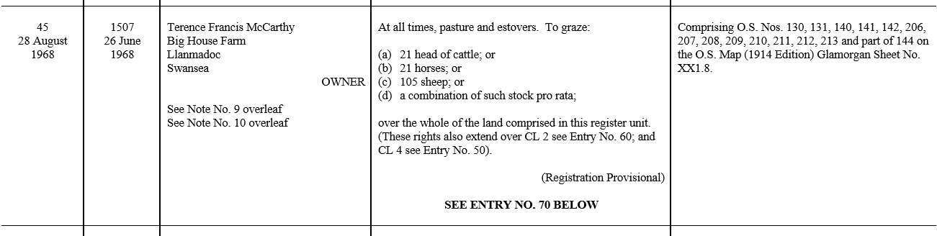

Rhan 2
Deddfau a digwyddiadau sy'n arwain at ddiwygiad

Tua 16 erw o dir a adwaenir fel y tir o Bayview, Llanmadoc ar 23 Chwefror 2023 drwy drawsgludiad er mwyn prynu'r tir.

Mae'r ymgeisydd yn honni bod dosraniad yn ddyledus ar yr hawliau sy'n gysylltiedig â'r tir a gaffaeliwyd yn unol â'r cofnodion yn y Gofrestr Tiroedd Comin.

Bydd hyn yn arwain i 2 gofnod newydd yn y gofrestr yn lle Cofnod Rhif 45 fel a
ddangosir yn Rhan 1 i hyn; un yn nodi'r hawliau fel y'u dosrennir i'r tir a ddaeth i feddiant yr ymgeisydd ac un ar gyfer y tir sy'n parhau o dan y cofrestriad gwreiddiol.

Rhan 3
Natur y diwygiad arfaethedig

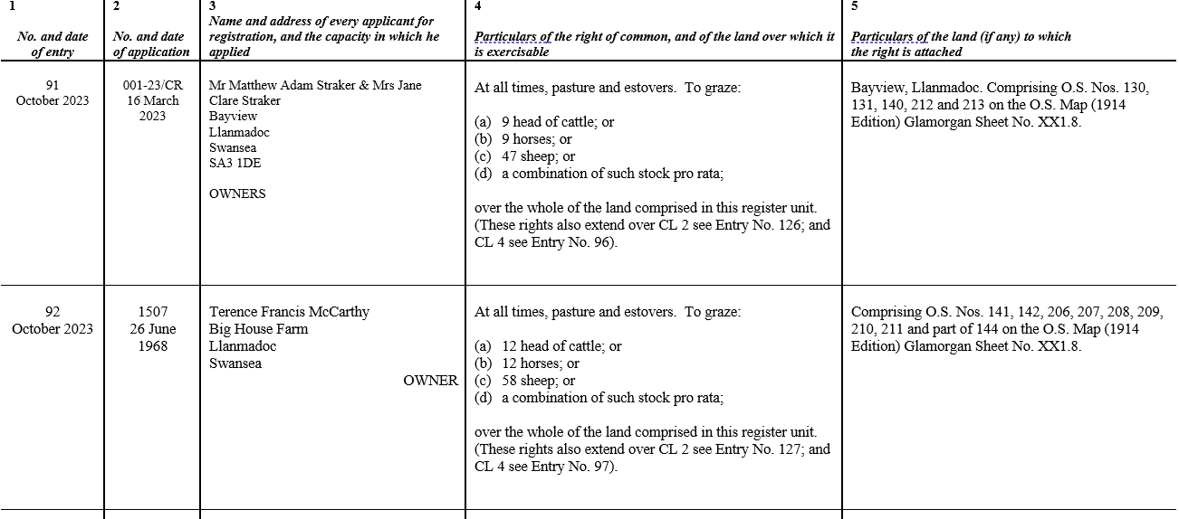

COMMONS REGISTRATION ACT 1965 – SECTION 13
Notice of Application for Amendment of Register

Rights of Common on Register Unit CL:003 Ryers Down Common

Application No: 001-23/CR

Application has been made to the City and County of Swansea by Mr Matthew Straker and Mrs Jane Straker of Bayview Farm, Llanmadoc, Swansea, SA3 1DE to amend the Register of Common Land in relation to the registered right of common of which particulars are given in part 1 of the Annex hereto. It is claimed that, by reason of the matters mentioned in part 2 of that Annex, the register ought to be amended as indicated in part 3 thereof.

Any person receiving this notice who wishes to object to the proposed amendment should, within forty days of the date of this notice, send a written and signed statement of the facts upon which he bases his objection to:

Directorate of Place
Planning and City Regeneration
Commons Registration Authority
Civic Centre,
Oystermouth Road
Swansea
SA1 3SN

Please quote reference: 001-23/CR

Dated this 19th October 2023

Annex

Part 1
Particulars of the right of common the registration of which is sought to be amended.

Register Unit CL:003 – Ryers Down Common

Part 2
Acts and events leading to amendment
The Applicant acquired approximately 16 acres of land at Bayview, Llanmadoc on 23rd
February 2023 through a conveyance for the purchase of land.

The applicant claims that an apportionment is due on the rights attached to the acquired
land as per the entries in the Register of Common Land.

This will result in 2 new entries into the register to replace Entry No. 45 as shown in Part 1 hereto; one setting out the rights as apportioned to the land acquired by the Applicant, and
one for the land remaining under the original registration.

Part 3
Nature of the proposed amendment

