THE COUNCIL OF THE CITY AND COUNTY OF SWANSEA
CYNGOR DINAS A SIR ABERTAWE
PROPOSED TRAFFIC REGULATION ORDER
PROHIBITION OF WAITING AT ANY TIME – QUEENS ROAD, MUMBLES WARD
NOTICE 2025

NOTICE is hereby given that the Council of the City and County of Swansea intends to make an Order in pursuance of its powers as contained in the Road Traffic Regulation Act 1984 (as amended) (“the Act”) the effect of which is as set out in the Schedule(s) below. A copy of the proposed Order, Statement of Reasons and an appropriate plan may be inspected during normal office hours at the Civic Centre Oystermouth Road Swansea SA1 3SN. Any objections to the proposals should be submitted in writing setting out the reasons thereto to reach the undersigned at the above address or via E-mail at Legal.TrafficNotices@swansea.gov.uk by the 8th August 2025 quoting reference DVT- 283768/EE

SCHEDULES

SCHEDULE 1
REVOCATIONS
The existing Orders are revoked as far as they are inconsistent with the proposals hereinafter contained which relate to the length or lengths of the road or roads referred to in the schedules hereto.
SCHEDULE 2
PROHIBITION OF WAITING AT ANY TIME
QUEENS ROAD (AT JUNCTION WITH WOODVILLE ROAD)
On the Southern side of Queens Road from its junction with the Western kerbline of Woodville Road for a distance of 18 metres in a westerly direction.
QUEENS ROAD (AT THE JUNCTION WITH CHAPEL STREET)
On the Northern side of Queens Road from its junction with the Wastern kerbline of Chapel Street for a distance of 13 metres in a westerly direction.
WOODVILLE ROAD (AT JUNCTION WITH QUEENS ROAD)
On the Western side of Woodville Road from its junction with the Southern kerbline of Queens Road for a distance of 10 metres in a southerly direction.
WOODVILLE ROAD (AT JUNCTION WITH GOWER PLACE)
On the Eastern side of Woodville Road from its junction with the Southern kerbline of Gower Place for a distance of 6 metres in a southerly direction.
CHAPEL STREET (AT JUNCTION WITH GOWER PLACE)
On the Eastern side of Chapel Street from its junction with northern kerbline of Gower Place for a distance of 20 metres in a northerly direction.
CHAPEL STREET (AT JUNCTION WITH QUEENS ROAD)
On the Western side of Chapel Street from its junction with the northern kerbline of Queens Road to the southern kerbline of Victoria Avenue.
GOWER PLACE (AT JUNCTIPON WITH CHAPEL STREET)
On the Northern side of Gower Place Road from its junction with the Eastern kerbline of Chapel Street for a distance of 39 metres in an easterly direction.
GOWER PLACE (AT JUNCTION WITH WOODVILLE ROAD)
On the southern side of Gower Place Road from its junction with the Eastern kerbline of Woodville Road to the Western kerbline of William Street.
SCHEDULE 3 – PROHIBITION OF WAITING AND PROHIBITION OF LOADING/ UNLOADING AT ANY TIME
LANGLAND ROAD (AT JUNCTION WITH QUEENS ROAD)
On the Eastern side of Langland Road from its junction with the Northern kerbline of Queens Road for a distance of 21 metres in a northerly direction.
On the Eastern side of Langland Road from its junction with the Southern kerbline of Queens Road for a distance of 10 metres in a southerly direction.
QUEENS ROAD (AT JUNCTION WITH LANGLAND ROAD)
On the Northern side of Queens Road from its junction with its eastern kerbline of Langland Road for a distance of 16 metres in an easterly direction
On the Southern side of Queens Road from its junction with the eastern kerbline of Langland Road for a distance of 17 metres in an easterly.


18th July 2025
L A Moore
Chief Legal Officer / Prif Swyddog Cyfreithiol

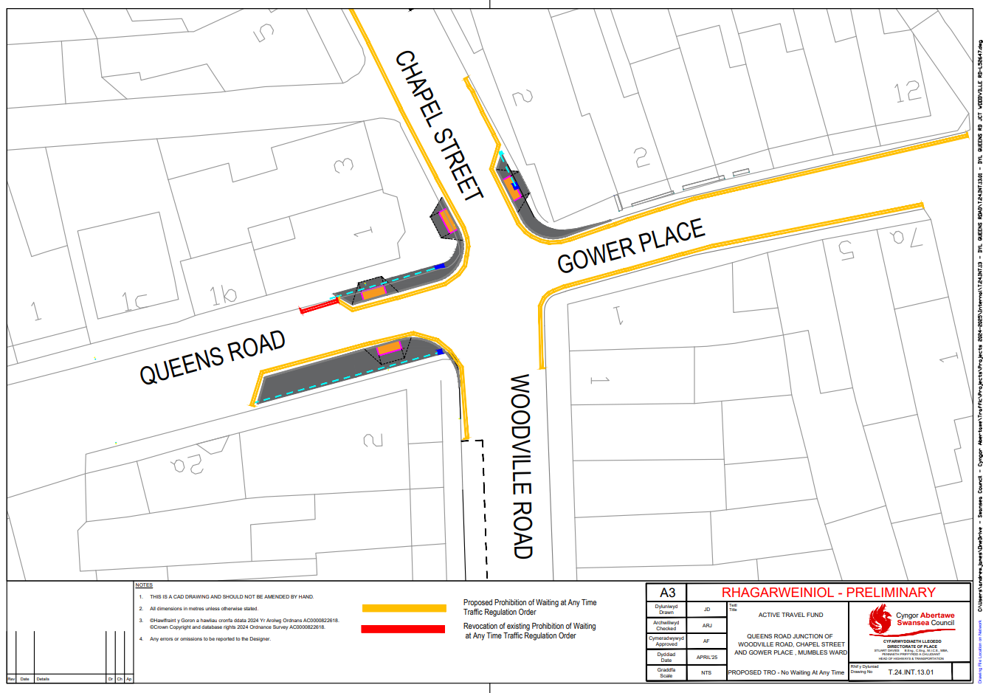
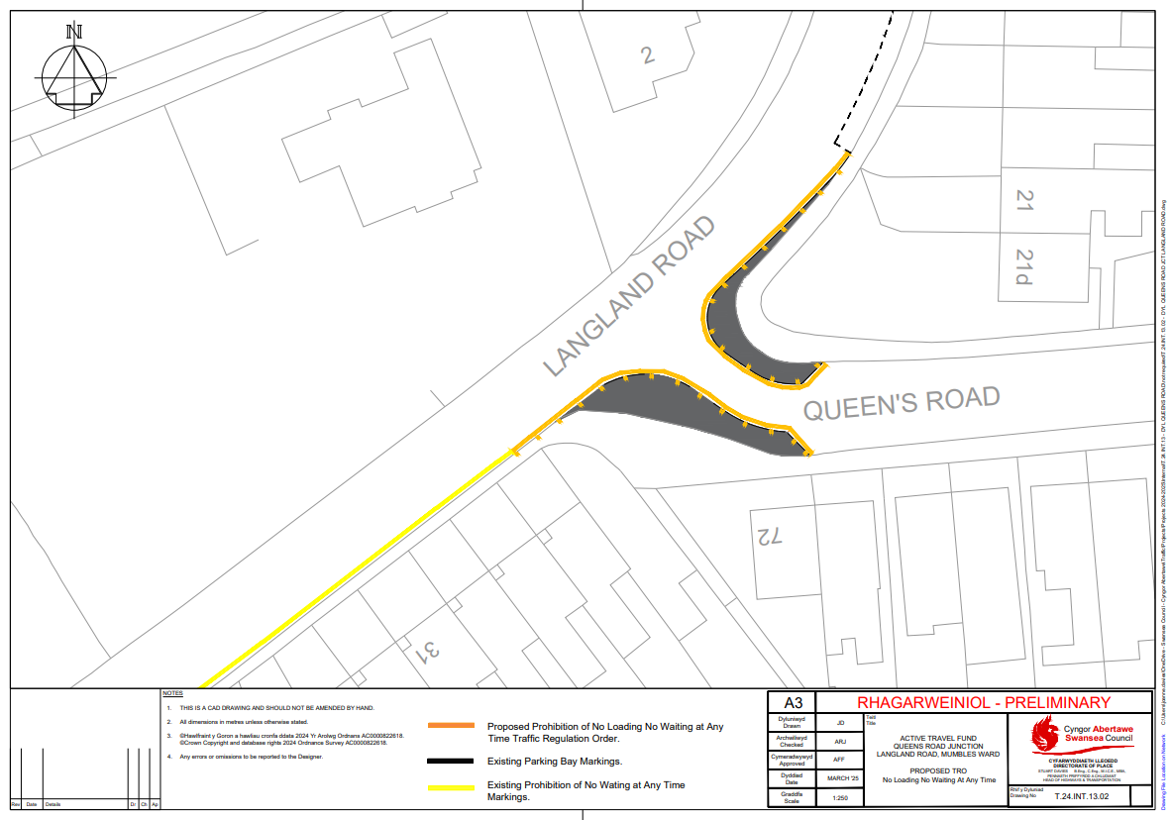

STATEMENT OF REASONS

Notice of Intent for the Traffic Regulation Order
PROPOSED TRAFFIC REGULATION ORDER
QUEENS ROAD, MUMBLES

The provision of :

Double yellow lines is for the purpose of improving road safety at road junctions for motorists and pedestrians.

Orders to be amended and Orders to be revoked are to reflect the current usage of the roads concerned.

STATEMENT OF REASONS

Notice of Intent for the Traffic Regulation Order

DYL QUEENS ROAD – MUMBLES WARD

The provision of :

- avoiding danger to persons or other traffic using the road or any other road or for preventing the likelihood of any such danger arising, or
- preventing the likelihood of any such danger arising
- for facilitating the passage of vehicular traffic on the road

Extract from Road Traffic Regulation Act 1984

2 What a traffic regulation order may provide.
(1)A traffic regulation order may make any provision prohibiting, restricting or regulating the use of a road, or of any part of the width of a road, by vehicular traffic, or by vehicular traffic of any class specified in the order,—
(a) either generally or subject to such exceptions as may be specified in the order or determined in a manner provided for by it, and
(b) subject to such exceptions as may be so specified or determined, either at all times or at times, on days or during periods so specified.

THE COUNCIL OF THE CITY

AND COUNTY OF SWANSEA

CYNGOR DINAS A SIR ABERTAWE



DRAFT

TRAFFIC REGULATION ORDER
PROHIBITION OF WAITING AT ANY TIME
QUEENS ROAD, MUMBLES
ORDER 2025

DVT- 283768/EE

THE COUNCIL OF THE CITY
AND COUNTY OF SWANSEA
CYNGOR DINAS A SIR ABERTAWE
TRAFFIC REGULATION ORDER
PROHIBITION OF WAITING AT ANY TIME
QUEENS ROAD, MUMBLES
ORDER 2025

THE COUNCIL OF THE CITY AND COUNTY OF SWANSEA (hereinafter called “the Council”) in exercise of its powers under Sections the Road Traffic Regulation Act 1984, as amended (hereinafter referred to as “the Act of 1984”) and the Traffic Management Act 2004 and the Local Government (Miscellaneous Provisions) Act 1976 and of all other enabling powers and after consultation with the Chief Officer of Police in accordance with Part III of Schedule 9 and Section 124 of the Act of 1984 hereby make the following Order.

SECTION 1 – PRELIMINARY
Citation and commencement

- This Order shall come into operation on XX XXXXXX 202X and may be cited as the Council of the City and County of Swansea, Traffic Regulation Order, Prohibition of Waiting at Any Time, Queens Road, Mumbles, Swansea Order 2025
Definitions
DRAFT

- In this order, except where the context otherwise requires, the following
expressions have the meaning hereby respectively assigned to them:

“Civil Enforcement Officer” has the same meaning as in Section 63A of the Act of 1984 and by virtue of Section 76 of the 2004 Act a Civil Enforcement Officer appointed under Section 63A of the Act of 1984 is a Civil Enforcement Officer in relation to parking contraventions;

“Disabled Person’s Vehicle” has the same meaning as in the Local Authorities’ Traffic Orders (Exemption for Disabled Persons) (Wales) Regulations 2000;

“Disabled Person’s Badge” has the same meaning as in the Disabled Persons (Badges for Motor Vehicles)(Wales) Regulation 2000;

“Parking Disc” means a disc and time clock (where appropriate) issued by a Local Authority complying with the requirements of the British Standard Specifications for Parking Discs to comply with the European Blue Badge Scheme being a disc coloured blue and capable of showing the quarter hour period during which a period of waiting begins;

“Relevant Position” in respect of:-

- a Disabled Person’s Badge and parking disc has the same meaning as in the Local Authorities’ Traffic Orders (Exemptions for Disabled Persons) (Wales) Regulations 2000; and

- a Waiver means exhibited on the windscreen, dashboard or fascia of the vehicle or, where the vehicle does not have a windscreen, dashboard or fascia, in a conspicuous position on the vehicle so that the whole of the information on the front of the waiver is clearly legible from outside the vehicle;

“Waiver” means a Waiver issued by the Council in respect of vehicles being used for building maintenance repair shop fitting or other industrial or demolition operations and the Council may charge for such waiver such charge to be determined from time to time by resolution of the Council or relevant Committee thereof;
DRAFT

Interpretation

- Except where otherwise stated, any reference in this Order to a numbered Article or Schedule is a reference to the Article or Schedule bearing that number in this Order

- The Interpretation Act 1978 shall apply for the interpretation of this Order as it applies for the Interpretation of an Act of Parliament

- The prohibitions and restrictions imposed by this Order shall be in addition to and not in derogation of any other prohibition or restriction whether made under the Act of 1984 or otherwise

SECTION 2 - NO WAITING AT ANY TIME

- Save as provided in Articles 7 and 8 no person shall, except upon the direction or with the permission of a Civil Enforcement Officer, police officer in uniform, or a person authorised by the Council, cause or permit any vehicle to wait at any time on the length or lengths of the road or roads referred to in Schedule 2 hereto.

Exemptions

- Nothing in Article 6 of this Order shall render it unlawful to cause or permit any vehicle to wait on the side or sides or length or lengths of the road or roads specified therein for as long as may be necessary to enable:-

- the vehicle, if it cannot conveniently be used for such purpose in any other road, to be used in connection with any of the following operations namely:-

- building, maintenance, repair, shop fitting or other industrial or demolition operations with a Waiver issued by the Council and displayed in the Relevant Position on the windscreen of the vehicle;

- the removal of any obstruction to traffic;
DRAFT
- the laying, erection, alteration or repair in or on land adjacent to the said lengths or sides of the road of any sewer or any main pipe or apparatus for the supply of water, gas electricity or of any telecommunications apparatus as defined by the Telecommunications Act 1984

- a vehicle being used for police, ambulance, fire brigade or other emergency purposes

- the vehicle if it cannot conveniently be used for such purpose in any other road, to be used in connection with the service of a local authority or of a water authority in pursuance of its statutory powers and duties.

- the vehicle of the Royal Mail or other universal services provider as defined in Section 27 of the Postal Services Act 2011 to be used for the purpose of delivering or collecting mail.

- vehicles picking up and dropping off passengers

- Nothing in Article 6 of this Order shall render it unlawful to cause or permit a Disabled Person’s Vehicle which displays in the Relevant Position a Disabled Persons Badge and a Parking Disc (on which the driver, or other person in charge of the vehicle, has marked the time at which the period of waiting began) to wait on lengths of sides of roads referred to in the Article for a period not exceeding 3 hours (not being a period separated by an interval of less than 1 hour from the previous period of waiting by the same vehicle on the same length of side of road on which that vehicle had previously been waiting.

REVOCATION
- The existing Orders are revoked insofar as they are inconsistent with the proposals contained in the schedules hereto and insofar as they relate to the length or lengths of the road or roads referred to in the Schedule hereto.

SCHEDULES

SCHEDULE 1
REVOCATIONS
The existing Orders are revoked as far as they are inconsistent with the proposals hereinafter contained which relate to the length or lengths of the road or roads referred to in the schedules hereto.
SCHEDULE 2
PROHIBITION OF WAITING AT ANY TIME
DRAFT
QUEENS ROAD (AT JUNCTION WITH WOODVILLE ROAD)
On the Southern side of Queens Road from its junction with the Western kerbline of Woodville Road for a distance of 18 metres in a westerly direction.
QUEENS ROAD (AT THE JUNCTION WITH CHAPEL STREET)
On the Northern side of Queens Road from its junction with the Wastern kerbline of Chapel Street for a distance of 13 metres in a westerly direction.
WOODVILLE ROAD (AT JUNCTION WITH QUEENS ROAD)
On the Western side of Woodville Road from its junction with the Southern kerbline of Queens Road for a distance of 10 metres in a southerly direction.
WOODVILLE ROAD (AT JUNCTION WITH GOWER PLACE)
On the Eastern side of Woodville Road from its junction with the Southern kerbline of Gower Place for a distance of 6 metres in a southerly direction.
CHAPEL STREET (AT JUNCTION WITH GOWER PLACE)
On the Eastern side of Chapel Street from its junction with northern kerbline of Gower Place for a distance of 20 metres in a northerly direction.
CHAPEL STREET (AT JUNCTION WITH QUEENS ROAD)
On the Western side of Chapel Street from its junction with the northern kerbline of Queens Road to the southern kerbline of Victoria Avenue.
GOWER PLACE (AT JUNCTIPON WITH CHAPEL STREET)
On the Northern side of Gower Place Road from its junction with the Eastern kerbline of Chapel Street for a distance of 39 metres in an easterly direction.
GOWER PLACE (AT JUNCTION WITH WOODVILLE ROAD)
On the southern side of Gower Place Road from its junction with the Eastern kerbline of Woodville Road to the Western kerbline of William Street.
SCHEDULE 3 – PROHIBITION OF WAITING AND PROHIBITION OF LOADING/ UNLOADING AT ANY TIME
DRAFT
LANGLAND ROAD (AT JUNCTION WITH QUEENS ROAD)
On the Eastern side of Langland Road from its junction with the Northern kerbline of Queens Road for a distance of 21 metres in a northerly direction.
On the Eastern side of Langland Road from its junction with the Southern kerbline of Queens Road for a distance of 10 metres in a southerly direction.
QUEENS ROAD (AT JUNCTION WITH LANGLAND ROAD)
On the Northern side of Queens Road from its junction with its eastern kerbline of Langland Road for a distance of 16 metres in an easterly direction
On the Southern side of Queens Road from its junction with the eastern kerbline of Langland Road for a distance of 17 metres in an easterly.

Dated this

THE COMMON SEAL OF THE )
COUNCIL OF THE CITY AND )
COUNTY OF SWANSEA )
was hereunto affixed )
in the presence of )

Authorised Signatory

